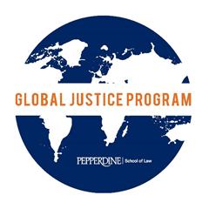

Global Justice Program
Application
Summer 2017

Name: Email:

Phone Number: Class year (circle one): 2017 2018 2019

Please list two faculty/staff members to serve as your references:
1)
2)

Please rank the programs for which you would like to be considered:
(1 is most preferred, please mark at least two choices)
If you are interested in a location that is not listed, indicate that in the space provided and make sure you have discussed this location with Jenna DeWalt.

___ Ugandan Judiciary
___ Rwandan Judiciary / Ministry of Justice
___ Paz y Esperanza, Peru or Ecuador (Fluent Spanish Required)
___ Council to Secure Justice, New Delhi, India
___ International Justice Initiative (IJI), Indonesia
___ Other (____________________________)

Please email the following in a single PDF file:
A. A one-page resume. If applicable, please include relevant languages skills and periods where you lived, worked, or studied abroad for more than 2 weeks consecutively.

B. A response to the question listed below. Responses should be typed and adhere to the following formatting guidelines: 10 or 12pt standard font, 1.5 spacing, standard margins, approximately one page in length.

Why do you desire to participate in this opportunity and how do you think that this experience will further your course of study at Pepperdine School of Law, as well as your career aspirations and life goals? If you strongly prefer placement in any one program, it is appropriate to include that information in this response, along with an explanation of why.

Please submit your completed application and supplemental documents to Jenna DeWalt at jenna.dewalt@pepperdine.edu by 4pm on December 1, 2016. Applications will be reviewed by a panel. Interviews will take place in January. You will be contacted by Jenna to schedule your interview.

Thank you for your interest in Pepperdine’s Global Justice Program. We are looking forward to reading your applications! It’s going to be a great summer!

